SYSTEM DESIGN
Data Flow Diagram / Use Case Diagram / Flow Diagram
The DFD is also called as bubble chart. It is a simple graphical formalism that can be used to represent a system in terms of the input data to the system, various processing carried out on these data, and the output data is generated by the system.
Data Flow Diagram:
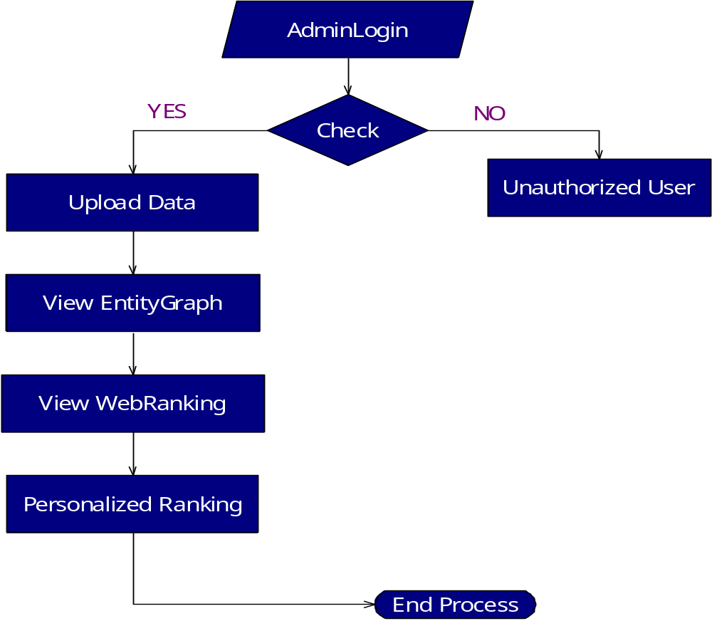

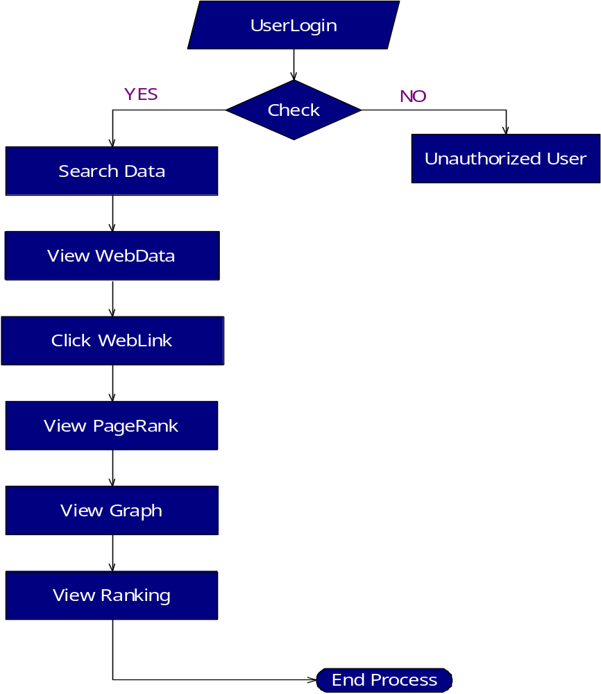

Component Diagram:
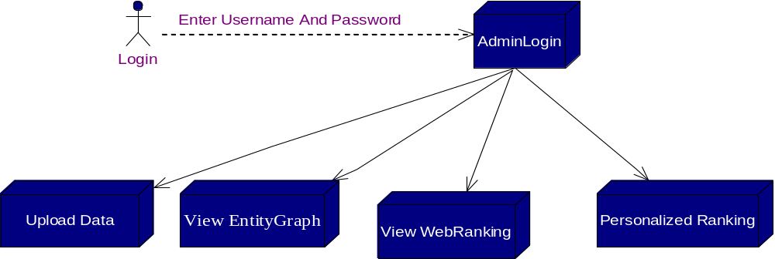

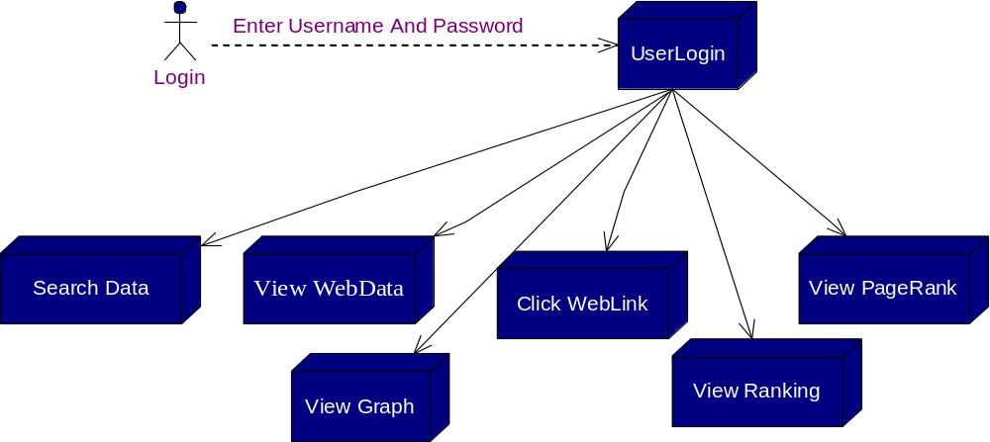

Use case Diagram
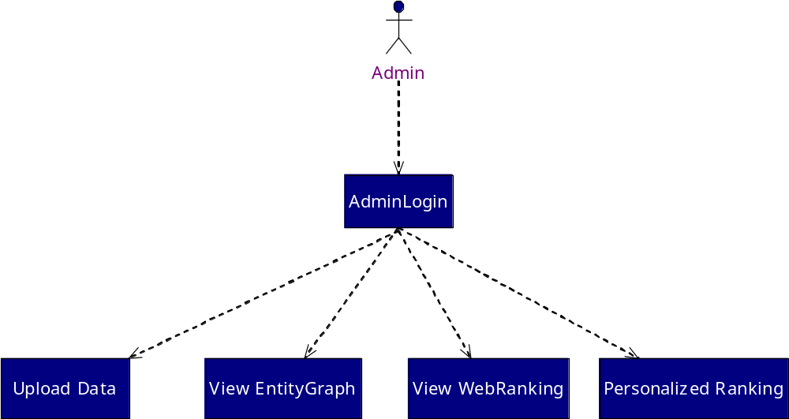

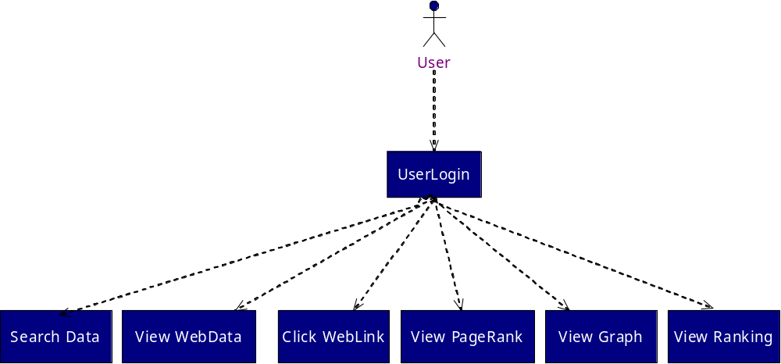

ACTIVITY DIAGRAM

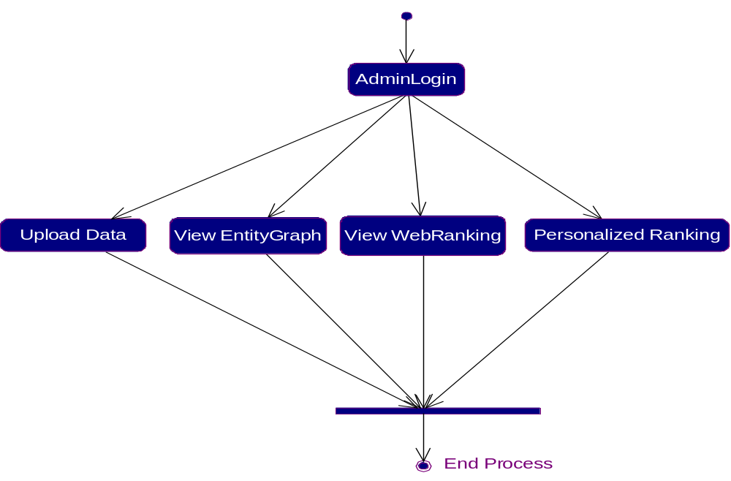
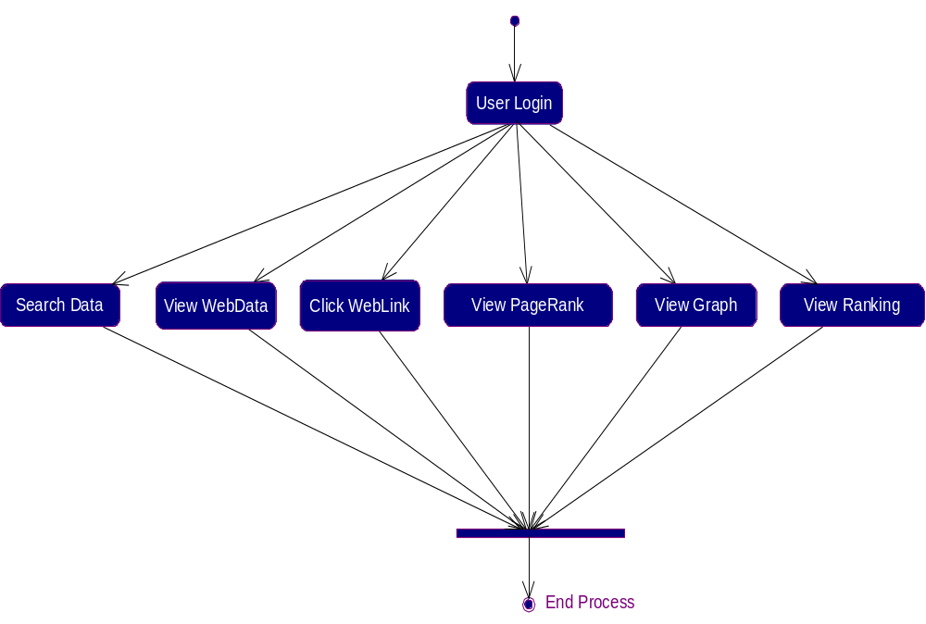

Sequence Diagram:

